Day-2 SQL Challenge
Day-2 Challenge:
Find all patients admitted to 'Surgery' service with a satisfaction score below 70, showing their patient_id, name, age, and satisfaction score.
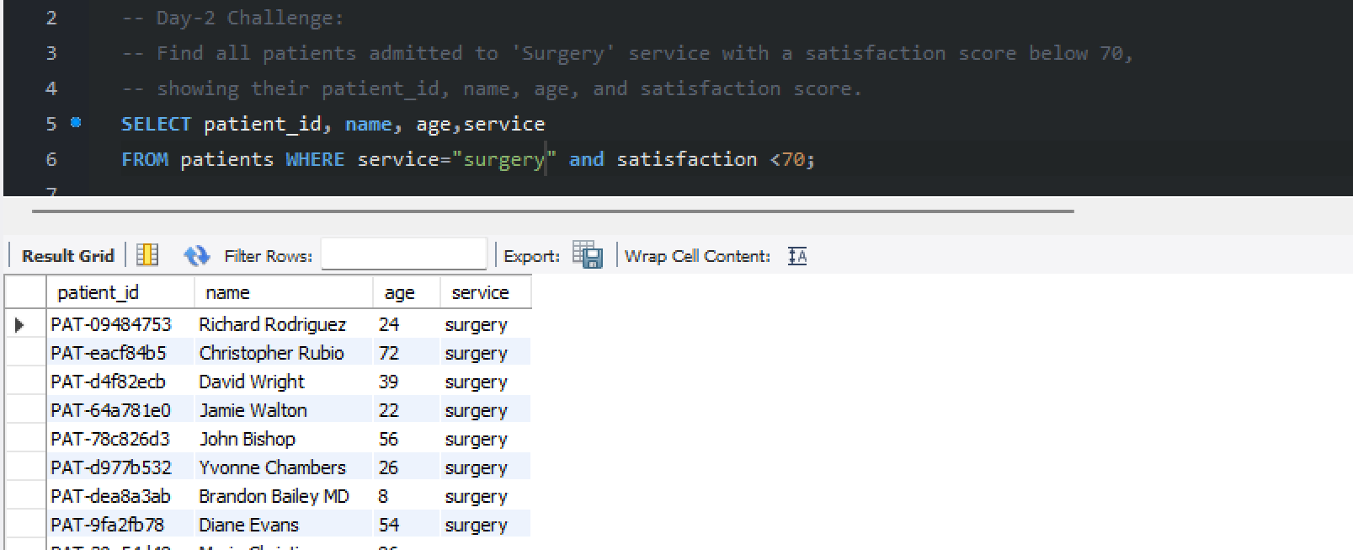

Practice Questions:
1. Find all patients who are older than 60 years.
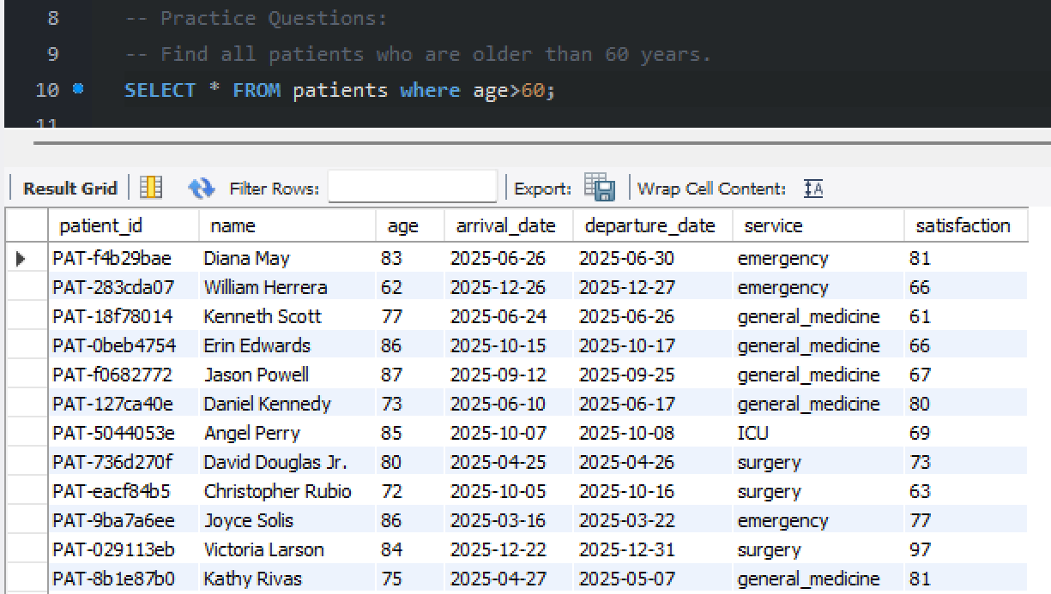

2. Retrieve all staff members who work in the 'Emergency' service.
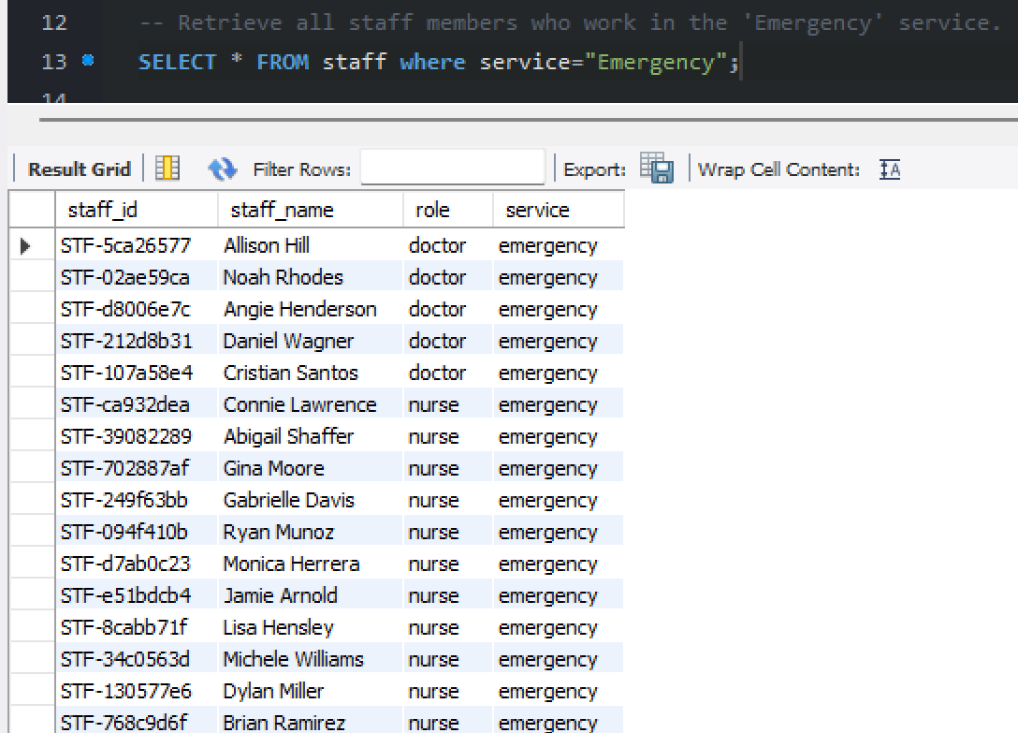

3. List all weeks where more than 100 patients requested admission in any service.
